IBM IOT Assignment 1: Interface piezo alarm with 2 sensor:PIR sensor and temperature sensor,

use these sensors along with piezo buzzer and write simple logic that the piezo alarm operates

whenever the temperature is above 60 degree centigrade and when ever the motion is

detected.

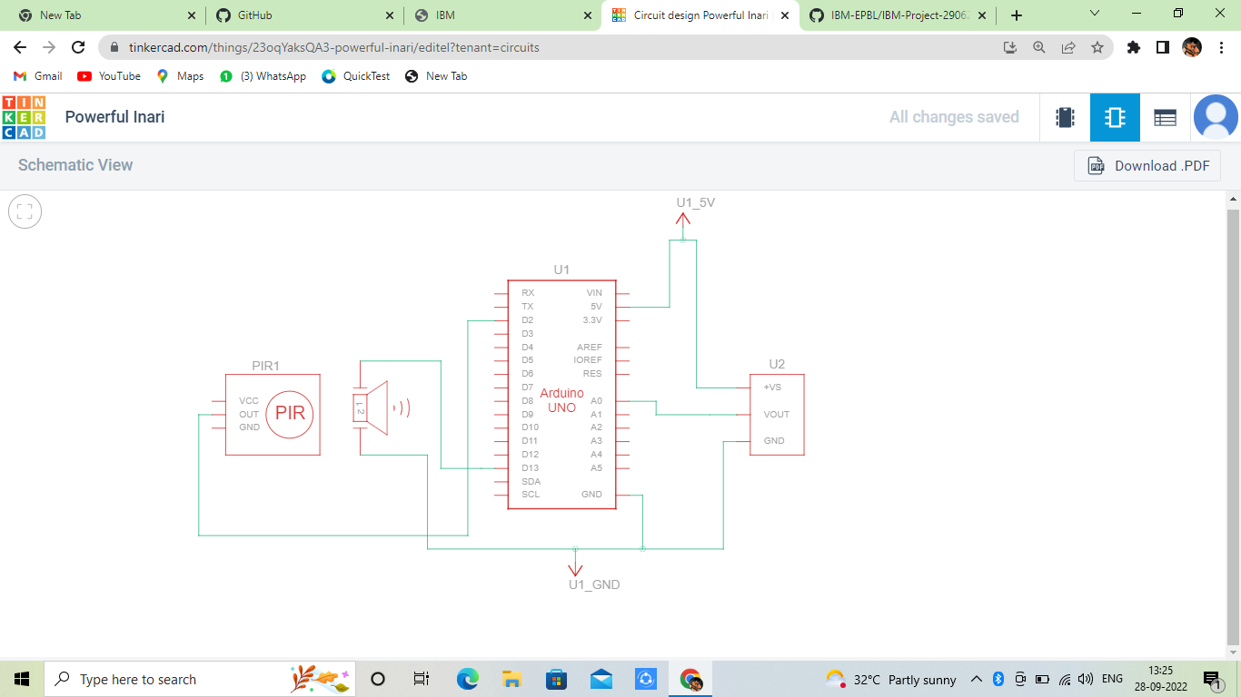

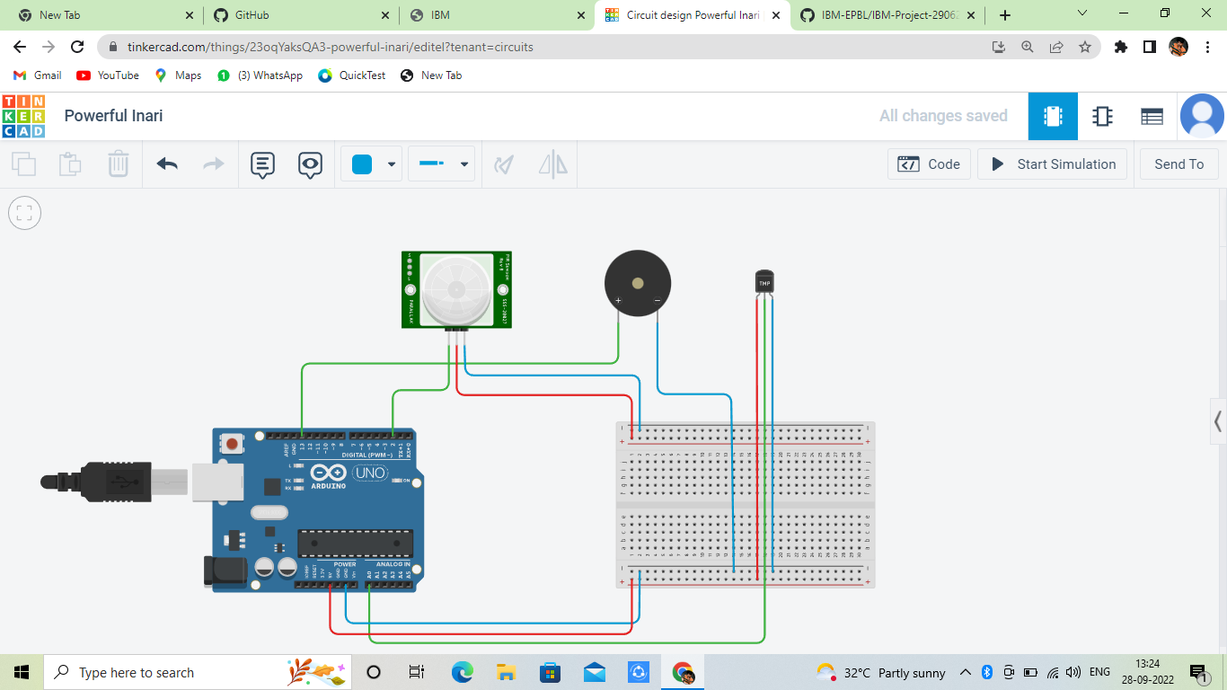

Code:

int baselineTemp = 0;

int celsius = 0;

int motion=digitalRead(2);

void setup()

{

pinMode(A0, INPUT);

pinMode(2, INPUT);

Serial.begin(9600);

pinMode(13, OUTPUT);

}

void loop()

{

baselineTemp =60; celsius = map(((analogRead(13) - 20) \* 3.04), 0, 1023, -40, 125);

if (celsius < baselineTemp)

{

digitalWrite(13, LOW);

} if (

celsius >

baselineTemp)

{

digitalWrite(13, HIGH);

for(int freq=0;freq<=30000;freq++)

tone(13, freq);

delay(1000);

noTone(12);

delay(500);

} if (

motion==1)

{

digitalWrite(13, HIGH);

for(int freq=0;freq<=30000;freq++)

tone(13, freq);

delay(1000);

noTone(12);

delay(500);

}

}